Comparing RunTimes between InsertionSort, MergeSort, and HeapSort

Homework #4

By

John Kiyak

CS303

September 25, 2018

**Problem Specification**

The goal of this assignment was the write a program that would implement the heapsort algorithim onto text files with arrays of varying sizes. Then, the program would print a result of the amount of time taken for each array read, with 7 results displayed in total over the course of 7 tests. The results from this test were then compared to the results from the previous two graphs, and were compiled into a table and graphs.

**Program Design**

This program required 3 classes, one for the main method, one for building the max heap, one for sorting the heap, and one for identifying the largest number.

The following steps were required to develop this program:

The main method was used to parse the test file and read the numbers into an array. It also defined the global variable heapsize and called the heapsort command with the array given as a parameter.

‘

The buildmaxheap class was used to define the heapsize, and call on the heapify class.

The heapsort class took the array that was given, and swapped the numbers around and called upon the heapify class with the new sorted array.

The heapify class identified the left and right bounds of the array depending on the heapsize.

The main method was called, which then ran the heapsort command, and displayed the amount of time that the array in question took to perform its operation.

**Testing Plan**

The testing plan was relatively simple. As with previous labs, inputs ranging from 100 to 500000 were put into the with open() command as the input file. The program was run 7 different times, with all results logged into an excel spreadsheet.

**Test Cases**

The test cases are shown in the table below:

HeapSort Array Size vs Execution Times

|  |  |
| --- | --- |
| Array Size | Execution Time |
| 100 | .0010 |
| 1000 | .0160 |
| 5000 | .0729 |
| 10000 | .1440 |
| 50000 | .8450 |
| 100000 | 1.7240 |
| 500000 | 10.2740 |

Graph of the above Table:

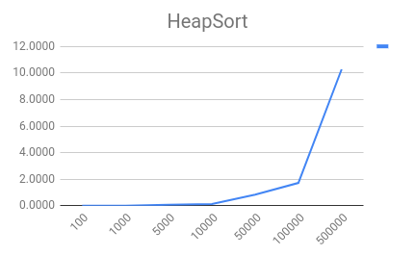

And here is a table comparing the execution times between InsertionSort, MergeSort, and HeapSort, along with graphs of the three:

|  |  |  |  |
| --- | --- | --- | --- |
| ArraySize | InsertionSort | MergeSort | HeapSort |
| 100 | 0.0000 | 0.0000 | 0.0000 |
| 1000 | 0.0780 | 0.0000 | 0.000 |
| 5000 | 2.0940 | 0.03126 | 0.0468 |
| 10000 | 7.9730 | 0.078 | 0.1093 |
| 50000 | 208.1000 | 0.4149 | 0.62501 |
| 100000 | 1029.7190 | 0.875 | 1.328 |
| 500000 | 27816.0000 | 5.1400 | 7.65 |

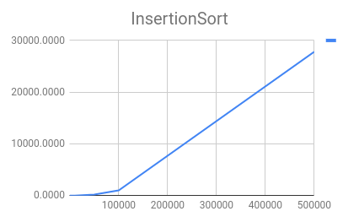

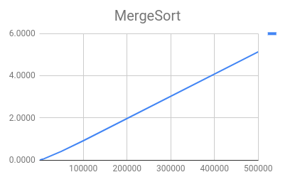

**Analysis and Conclusions**

For these, it is important to think about the big O notation for each of these, considering the best, worst and average case.

For insertion sort, the worst case and average case is O(n^2) and the best case in O(n).

For merge sort, the worst, average and best case are all O(n log n).

For heapsort, it has a worst case of O(n log n) and a best case of O(n log n).

Using the above results, we can confirm that the higher an array goes, it becomes more sense to use merge sort if sorted an array. Heapsort keeps up with mergesort for the most part in the first 3 tests, and then starts to differ slightly, by around 2 seconds at the array length of 500000. This is best illustrated in the fact that by that the worst, average, and best case for both merge sort and heapsort are both the same.

**References**

I used geeks for geeks to get started on my heapsort, and used the textbook for the big O times for the algorithims.

**Recurrence Expressions:**

Attatched is my work for the 2 recurrence expressions:

